Report

Team ID | MCA
Project Name | Heart Disease Risk and Patient Health Analysis
Maximum Marks | 5 Marks

About This Report
A report is a comprehensive document that provides a detailed and structured account of data analysis, findings, and insights. It is typically used for in-depth analysis, documentation, and communication of results. Reports are suitable for a diverse audience, including decision-makers, analysts, and stakeholders who need a comprehensive understanding of the data.
Designing a report in Power BI involves connecting to data sources, creating visualizations like charts and graphs, customizing their appearance and interactivity, organizing them logically on the canvas, formatting elements for consistency and clarity, and optionally creating dashboards for a summarized view. Throughout the process, it's essential to consider the audience's needs and ensure the report effectively communicates insights from the data. Finally, iterate based on feedback to continually improve the report's design and usefulness.
Key Summary Metrics
Metric Description | Average Value / Count
Average Diet Quality Score | 59.47
Average Total Cholesterol | 188.75
Average BMI | 25.26
Average Stress Score | 47.97

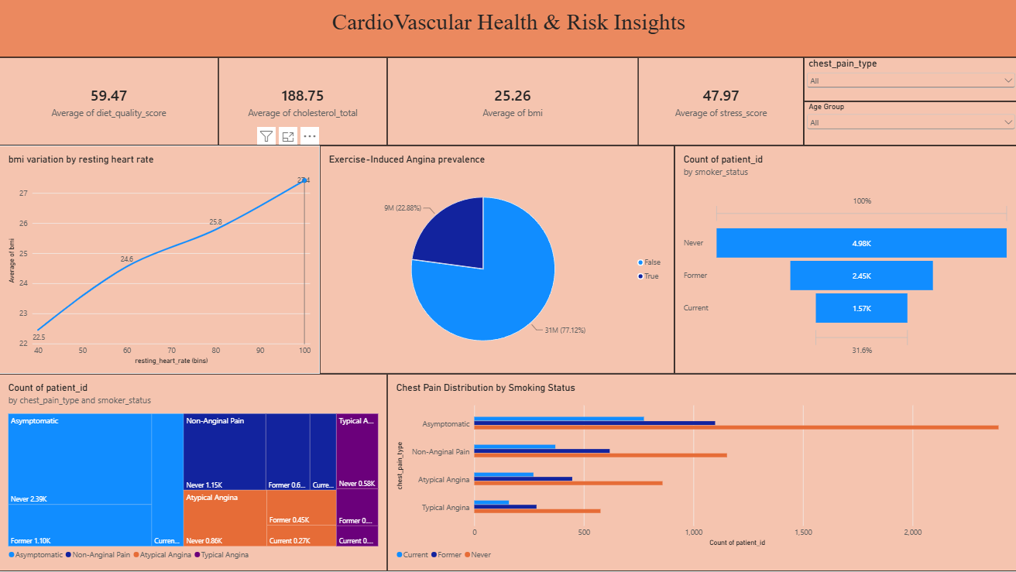
Observations Drawn from Dashboard
Observations drawn from reports in Power BI provide valuable insights into cohort medical risks, habits, and physiological trends.
1. BMI and Resting Heart Rate Correlation:
The line chart demonstrates a clear upward trend showing that average BMI increases continuously with higher resting heart rate bins, rising from an average BMI of 22.5 at a resting heart rate of 40 bpm up to a peak average BMI of 27.1 at a heart rate of 100 bpm.
2. Exercise-Induced Angina Prevalence:
A significant portion of the patient cohort experiences exercise-induced angina, with 22.88% (9 million patients) testing positive (True) for the condition, while 77.12% (31 million patients) do not experience it.
3. Smoking Status Distribution:
The absolute patient volume breakdown indicates that individuals who have never smoked represent the largest demographic subgroup at roughly 4.98K patients, followed by former smokers at 2.45K, and current smokers at 1.57K.
4. Chest Pain Type and Demographics:
Asymptomatic chest pain is highly prevalent across all patient strata, particularly dominant among those who have never smoked (2.39K patients) and former smokers (1.10K patients). Non-anginal pain presents the next most common classification, with 1.15K patients in the 'Never smoked' category.

